Name: ____________________
Roll Stamp Design Sheet
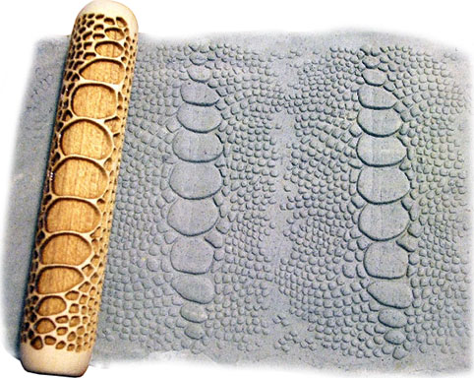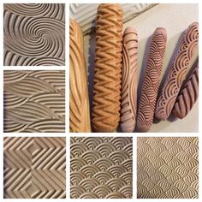
Directions: Draw 3 ideas for your roll stamp. Remember this will be carved into clay so make sure the lines are thick enough. Look at my design idea sheets for help. The darkened in areas will be carved into the stamp. You should have equal parts carved and uncarved. If you are planning on cutting out your stamp design and stippling it onto the clay you will for sure want to continue the design all the way to the end of the rectangle. If you are planning on free handing your design onto the clay you have to at least draw to the dotted line. Example:
Stamp will roll this direction

